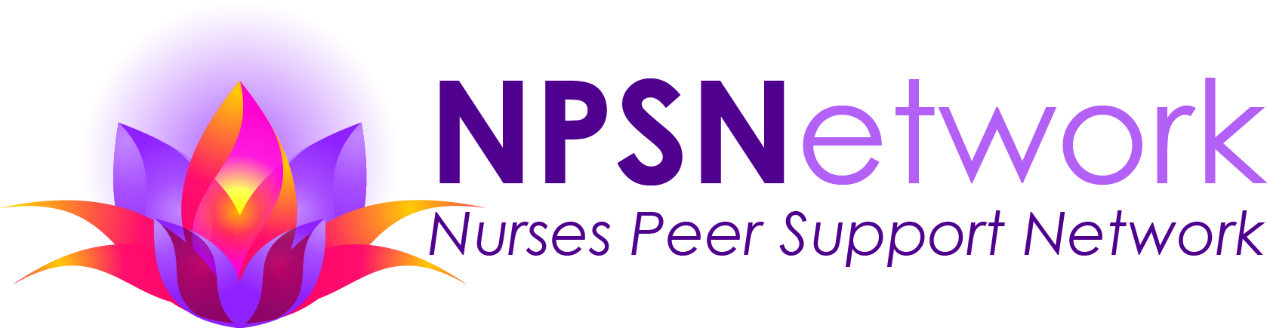
NPSN Responsibility Statement
(Read out loud together at NPSN Peer Support Meetings)

As your peer with a shard goal of mutual recovery, I commit to the following:

- I accept responsibility for listening carefully, speaking truthfully and maintaining confidentiality. Confidentiality is extremely important. Most persons present are mandated reporters. When speaking of reportable offenses, we ask that you phrase it as a hypothetical situation, therefore, this information will be considered hearsay and not fall in the realm of mandatory reporting.
- I will be trustworthy in my peer-to-peer communication and expect others to do the same.
- My relationship with all peers will be equally respectful, regardless of type of addiction, time in recovery, age, gender, sexual orientation, or any other differences that may exist between use.
- I commit to not engaging in cross talk and will listen intently to understand first, and then to be understood.
- I will be direct with my communication and commit to not gossiping. If I hear you doing so, I will ask that you speak with that person(s) directly.
- I am committed to group unity, as peer support is key for each of us to maintain a healthy recovery.
10/2019

