Substance Use Disorder Treatment Options and Supports for Nurses
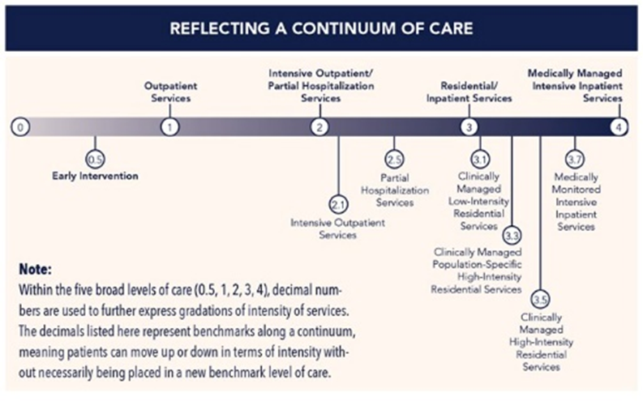
Courtesy of Asamcontinuum.org
Treatment Levels of Care
Level 1: Outpatient Services (OP) - Less than 9 hours of services/week
Level 2.1: Intensive Outpatient Services (IOP) - 9 or more hours of services/week
Level 2.5: Partial Hospitalization Services (Day Treatment) - 20 hours or more of services/week
Level 3.5: Clinically Managed Medium–Intensity Residential Services - 24 hour care by trained counselors to deal with multidimensional acuity

Outpatient Treatments (Level 1 – 2.5)
- Outpatient (9), Intensive Outpatient (9+), Day Treatment (20+)
- Least restrictive, decreased cost
- Identifiable outcomes and goals
- Scheduled sessions (group/individual)
- Combination of learning and application of coping strategies, therapy
- Some treatment specific models (12 step approach) and/or focus on education, coping skills, therapy and behavior management
- Addressing attitude and behaviors to increase skill in maintaining sobriety
- Some individuals still work in these LOC
- Often recommended to attend support meetings outside of treatment
- Can be combined with sober living or structured living

Inpatient Treatment (Level 3.1-3.7)
- Clinically managed residential services – 24 hour structured support, clinical staff with ability to deal with multiple complex issues (withdrawal, medical, mental health/cognitive, interpersonal)
- Most restrictive, increased cost, may or may not be covered by insurance
- Generally very scheduled, regimented routines, enhance behavior changes
- Removes individual from their environment, focus on treatment
- Ability to assist individual with complex issues (trauma/PTSD, prolonged withdrawal, medical complications, and co-occurring MH diagnosis/treatment)
- Individuals usually have poor coping skills, low stress tolerance, and risky living environments
- Individualized outcomes and goals with scheduled sessions (group/individual)
- Combination of learning and application of coping strategies, education, therapies, some specific model (12 step, cognitive behavioral, etc.) approach
- Addressing attitude and behaviors to increase skill in maintaining sobriety

Medicated Assisted Treatment (MAT)
- Use of medications to assist with withdrawal, cravings and symptom management
- May be short or long term treatment (few days to years)
- May be combined with inpatient/outpatient treatment
- May decrease chances of relapse by reducing cravings
- Medications used:
  - Alcohol - Campral (acamprosate), Naltrexone
  - Opioids – Naltrexone, Vivitrol, Methadone, Suboxone (buprenorphine/naloxone)
- Has addictive risks – Methadone, Buprenorphine/Naloxone
- Vivitrol (opioid antagonist) - Extended release Naltrexone once monthly injection, blocks opioid receptors in brain, prevents intoxication/reward, reduces cravings
- Buprenorphine/Naloxone (partial opioid agonist): Activates opiate receptors, but not to degree of opioids and blocks effects of other opioids, reduces cravings

Additional Treatment Recommendations for Nurses/Special Populations by ASAM
- Identifies nurses as safety-sensitive workers, with a responsibility to the public due to nature of their work
- Asserts that helping one individual nurse helps the profession, likewise, when one nurse relapses it hurts the profession at large
- Treatment is most effective in a cohort-specific program, which allows for self-disclosure, processing of shame, and acceptance of self
- Nurses have access to controlled substances and treatment should address returning to access and work environment issues
- Nurses struggle being in the patient role versus the caregiver and need experienced clinical staff who understand this challenge
- Profession specific treatment groups
- Aggressive treatment, often requires a more intensive level of care (LOC) and monitoring
- Often nurses allowed one chance to recover, should not “fail first” at lower LOC

Resources
Center for Substance Abuse Treatment. Medication-Assisted Treatment for Opioid Addiction in Opioid Treatment Programs. Treatment Improvement Protocol (TIP) Series 43. HHS Publication No. (SMA) 12-4214. Rockville, MD: Substance Abuse and Mental Health Services Administration, 2005. Retrieved from http://store.samhsa.gov/shin/content/SMA12-4214/SMA12-4214.pdf
Mee-Lee, David. (Eds.) (2013) The ASAM criteria: treatment for addictive, substance-related, and co-occurring conditions. Chevy Chase, MD: American Society of Addiction Medicine.
National Council of State Boards of Nursing (NCSBN). (2011). Substance use disorder in nursing: A resource manual and guidelines for alternative and disciplinary monitoring programs. Chicago, IL: NCSBN.
National Institute of Drug Abuse (NIDA), 2012. Principles of drug addiction treatment: A research based guide (3rd ed.) (NIH Publication No. 12-4180). Retrieved from http://www.drugabuse.gov/publications/principles-drug-addiction-treatment

